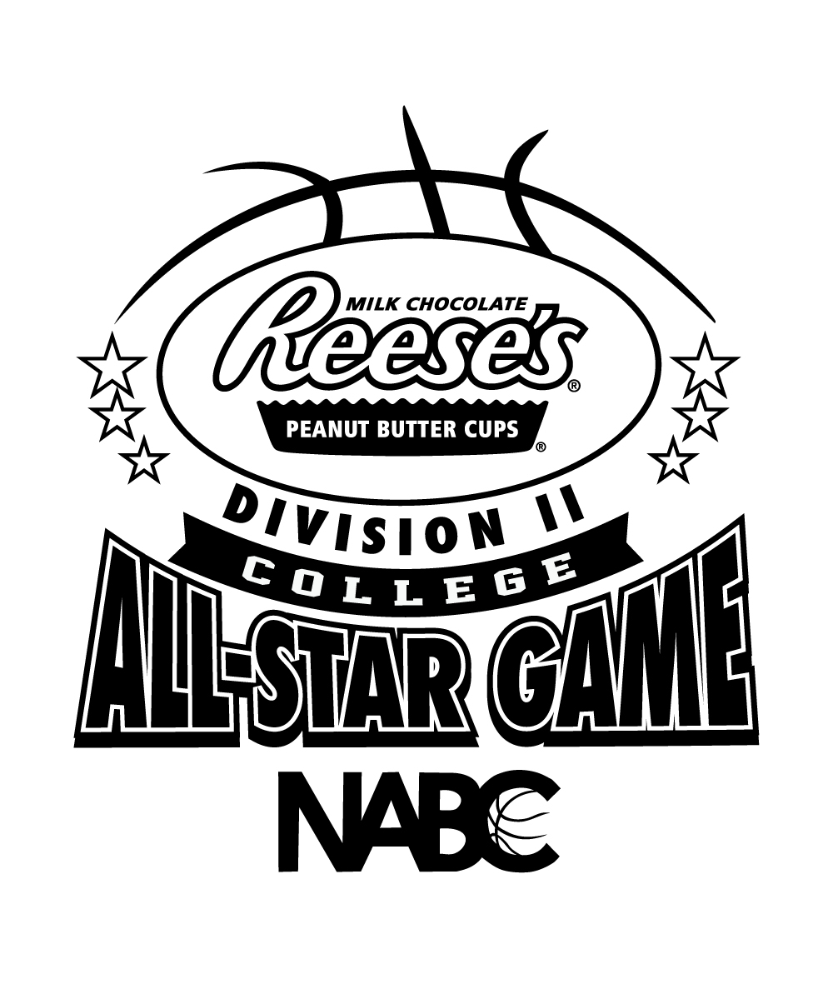

**2016 *Reese’s* Division II College All-Star Game**

**Friday, March 25, 2016 Dr. Pepper Arena – Frisco, Texas**

**EAST**

**No. Name Ht. Pos. College/University Hometown**

1 Rodnerius Lewis 6-4 G Stillman Memphis, Tenn.

3 Andy Mazurczak 6-2 G UW-Parkside Norridge, Ill.

5 Keenan Palmore 6-2 G Lenoir-Rhyne Stone Mountain, Ga.

11Desmond Williams 6-5 G Southern Connecticut Torrington, Conn.

15 Rodney Sanders 6-4 G/F Southern New Hampshire Elizabeth, N.J.

21 Peter Alexis 7-0 F Philadelphia University Wilkes-Barre, Pa.

23 Brandon Norfleet 6-5 G IUP Virginia Beach, Va.

24 Kyle Cooper 6-7 F Hillsdale Northville, Mich.

31 Eric Seifert 6-4 G Wheeling Jesuit Reynoldsburg, Ohio

55 Isaac Sevlie 6-9 F/C Minnesota State Moorhead Red Wing, Minn.

**Head Coach:** Larry Gipson(Northeastern State)

**WEST**

**No. Name Ht. Pos. College/University Hometown**

3 Kameron Bundy 6-2 G Drury Nixa, Mo. 5 Joey Miller 6-3 G Dallas Baptist San Marcos, Tex.

12 Greg Gardner 6-5 G UAH Indianapolis, Ind.

15 Dylan Travis 6-3 G Florida Southern Omaha, Neb.

23 Ryan Stephan 6-10 C Colorado Mesa Lakewood, Col.

24 Terrell Harris 6-3 G Georgia College Indiantown, Fla. 25 Alex Welsh 6-7 F UC Colorado Springs Westminster, Colo.

32 Mark Ogden, Jr. 6-9 F Dixie State Spring Valley, Calif.

40 Jordan Faison 6-7 F Cal Poly Pomona Lake Forest, Calif.

55 Taevaunn Prince 6-3 G Missouri Southern State Toronto, Ontario

**Head Coach:** Gene Iba (Pittsburg State)