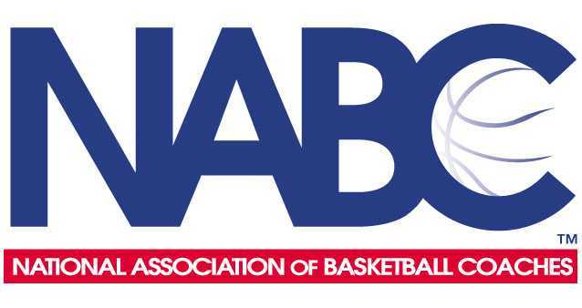
FOR IMMEDIATE RELEASE Contact: Rick Leddy, NABC 203-815-2437 (Ricknabc@gmail.com)

National Association of Basketball Coaches Announces

2016 Coaches’ Division II All-District Teams and Coaches

KANSAS CITY, Mo. (March 22, 2016) -- The National Association of Basketball Coaches (NABC) announced today the 2016 NABC Coaches’ Division II All-District teams and coaches, recognizing the best men’s collegiate basketball student-athletes and coaches in the division. Selected and voted on by member coaches of the NABC in NCAA Division II, these 88 student-athletes represent the finest basketball players across America.

2016 NABC COACHES’ DIVISION II ALL-DISTRICT TEAMS AND COACHES

Atlantic
First Team Second Team
Seger Bonifant, West Liberty AJ Leahy, Pitt-Johnstown

Matt Bigaya, Fairmont State Rob Reed, Concord

Tyree Gaiter, Notre Dame College Dustin Sleve, Shippensburg

Brandon Norfleet, IUP Kameron Taylor, Seton Hill

Eric Seifert, Wheeling Jesuit Matt Wisely, West Chester

Jaymon Mason, Edinboro

Coach of the Year: Danny Sancomb, Wheeling Jesuit

Central
First Team Second Team
Connor Beranek, Nebraska Kearney Cory Arentsen, Lindenwood
Dan Jansen, Augustana Jacob Gibson, Harding
Justin Pitts, Northwest Missouri State Pierre Newton, Minnesota-Duluth
Tevaunn Prince, Missouri Southern State Jalen Pendleton, Minnesota State Mankato
Casey Schilling, Augustana Alex Richter, Augustana
Isaac Sevlie, Minnesota State Moorhead

Coach of the Year: Tom Billeter, Augustana

East
First Team Second Team
Peter Alexis, Philadelphia Reggie Charles, Holy Family
Michael Mallory, Southern Connecticut Sho Da-Silva, USciences
Mike McCahey, St. Anselm Keegan Hyland, Bentley
Tyler McFarland, Bentley Ryan Logan, Stonehill
Rodney Sanders, Southern New Hampshire Justin Reyes, St. Thomas Aquinas
Desmond Williams, Southern Connecticut

Coach of the Year: Tobin Anderson, St. Thomas Aquinas

Midwest
First Team Second Team
Kameron Bundy, Drury Kyle Cooper, Hillsdale
Wendell Davis, Ashland Devin Daly, Lake Superior State
Andy Mazurczak, UW Parkside Jesse Hardin, Jr., Walsh
Max Strus, Lewis Jordan Loyd, Indianapolis
Rusty Troutman, Bellarmine Jared Stolicker, Ferris State
C.J. Turnage, Saginaw Valley State

Coach of the Year: Luke Reigel, UW Parkside

South
First Team Second Team
Yunio Barrueta, Barry Marterrace Brock, Union
Marcus Dewberry, Saint Leo Greg Gardner, UAH
Rodnerius Lewis, Stillman Jeff Merton, Rollins
Devin Schmidt, Delta State Chris Page, Nova Southeastern
Phil Taylor, Shorter Dylan Travis, Florida Southern
Seab Webster, UAH

Coach of the Year: Lennie Acuff, University of Alabama in Huntsville

South Central
First Team Second Team
Tre Bennett, Angelo State Khapri Alston, Midwestern State
Joshua Blaylock, Fort Lewis Gokul Natesan, Colorado Mines
David Chavlovich, West Texas A&M EJ Reed, Tarleton State
JC Hartzler, Rogers State Alex Welsh, UC Colorado Springs
Joey Miller, Dallas Baptist
John Moon, Oklahoma Christian
Ryan Stephan, Colorado Mesa

Coach of the Year: Bob Pietrack, Fort Lewis

Southeast
First Team Second Team
Luquon Choice, Lincoln Memorial Austin Anderson, Lees-McRae
Charles Clark, Carson-Newman C.J. Good, King
Terrell Harris, Georgia College Sean Morgan, Queens
Rob Lewis, Queens Keshun Sherrill, Augusta
Keenan Palmore, Lenoir-Rhyne C.J. Wilson, Young Harris
Gerel Simmons, Lincoln Memorial

Coach of the Year: Josh Schertz, Lincoln Memorial

West
First Team Second Team
Andy Avgi, Western Oregon Drew Dyer, UC San Diego
Robert Duncan, Chico State Scott Friel, BYU-Hawaii
Jordan Faison, Cal Poly Pomona Stephen Grosey, Concordia-Irvine
Mark Ogden, Jr., Dixie State Mitch Penner, Seattle Pacific
Michael Smith, California Baptist Travante Williams, Alaska-Fairbanks
Sekou Wiggs, Alaska-Anchorage

Coach of the Year: Jim Shaw, Western Oregon

(NABC Division II All-District -- page 3)

About the National Association of Basketball Coaches
Located in Kansas City, MO, the NABC was founded in 1927 by Forrest “Phog” Allen, the legendary basketball coach at the University of Kansas. Allen, a student of James Naismith, the inventor of basketball, organized coaches into this collective group to serve as Guardians of the Game. The NABC currently has nearly 5,000 members consisting primarily of university and college men’s basketball coaches. All members of the NABC are expected to uphold the core values of being a Guardian of the Game by bringing attention to the positive aspects of the sport of basketball and the role coaches play in the academic and athletic lives of today’s student-athletes. The four core values of being a Guardian of the Game are advocacy, leadership, service and education. Additional information about the NABC, its programs and membership, can be found at www.nabc.org.

##

